| **Test Name** | Automated Operations: No Stop Message if Pump Not Running |
| --- | --- |
| **Use Case Tested:** | Automated Operations |
| **Test Description:** | Verifies business rules/automation do nothing when tank level is above high threshold and pump is not running. |
| **Pre-conditions** | * Pump not running * Dashboard state of pump: not running. * ThingsBoard has not asked the pump to start running via manual operation. * Automatic control is enabled. * The “switch pump of when tank level is above” field is set to 2 metres. * The current tank level is >= 2 metres. |
| **Post-conditions** | No change to system. Pump remains off. |
| **Notes:** | **This test can be run immediately after BPST004, the pre-conditions will be met.**  **Negative test. No change in system state should be observed.** |

|  | **TEST STEP** | **EXPECTED TEST RESULTS** |
| --- | --- | --- |
|  | Use Simulator to send tank sensor message with a level of 2.1 metres. | No changes in UI or state of pump controller other than the tank level indicator. |
|  | Command the pump controller to send a status message. | No change to System. Business rules have not sent a message to start the pump as the pump is in a state of not running. |

|  |  |  |  |  |  |
| --- | --- | --- | --- | --- | --- |
| **Test Data Table** | | | | | |
|  | **1** | **2** | **3** | **4** | **5** |
| [Data field 1] | [data set 1 input value for field 1] |  |  |  |  |
| [Data field 2] | [data set 1 input value for field 2] |  |  |  |  |
| [Data field 3] | [data set 1 input value for field 3] |  |  |  |  |

Results

26/08/2020

Passed. The automatic off in the screen shot is the same message as in the previous test, see the timestamp.

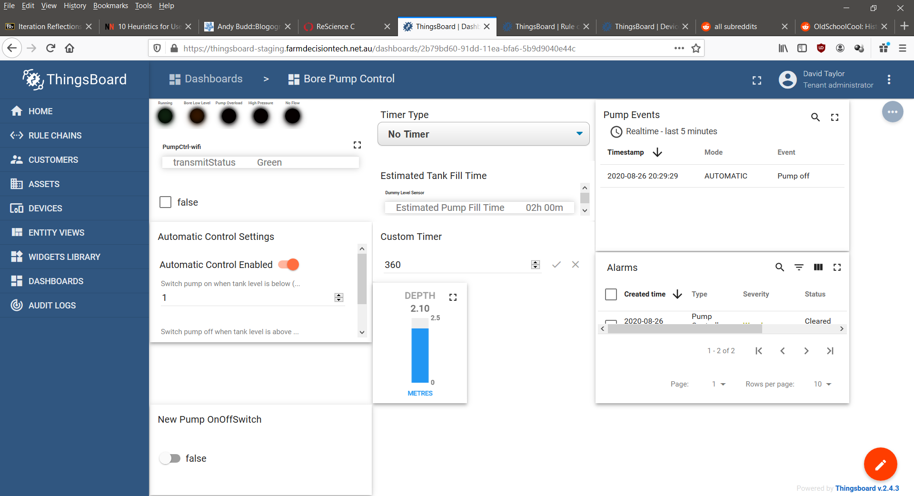

02/09/2020

Passed

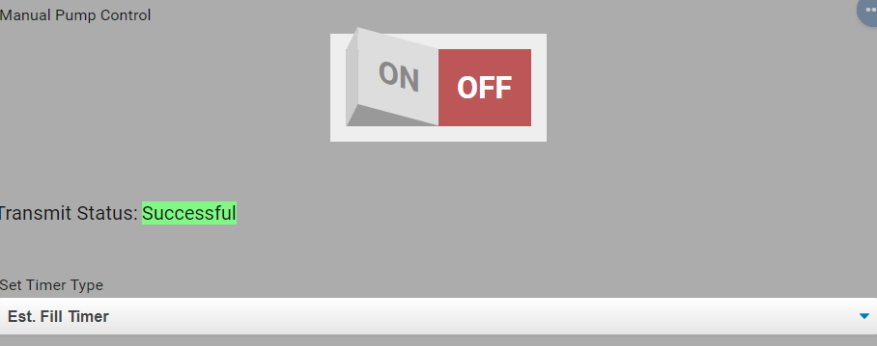

9/9/2020 – On site test at OAI.

Success.

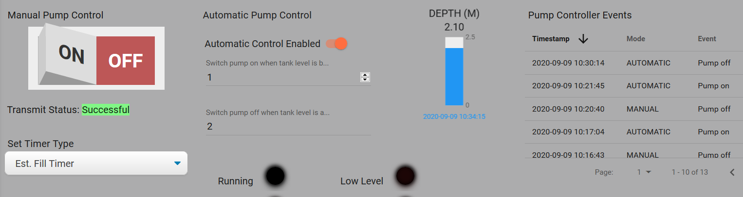

10:34:58.785 -> Send operator requested status message.

10:34:58.785 -> LoRaWAN will encode and send this message: {'pumpRunning':0,'boreLowLevel':0,'softStartFail':0,'pumpOverload':0,'controllerRestart':0,'highPressure':0,'noFlow':0}

10:34:58.785 -> Sending status byte: 00

10:35:00.919 -> EV_TXCOMPLETE (includes waiting for RX windows)